**ASSIGNMENT 2 – IMPLICIT INTENTS**

1. Below screen is the “Main Activity” of this app. It has 2 text view fields “URL” and “PHONE”.

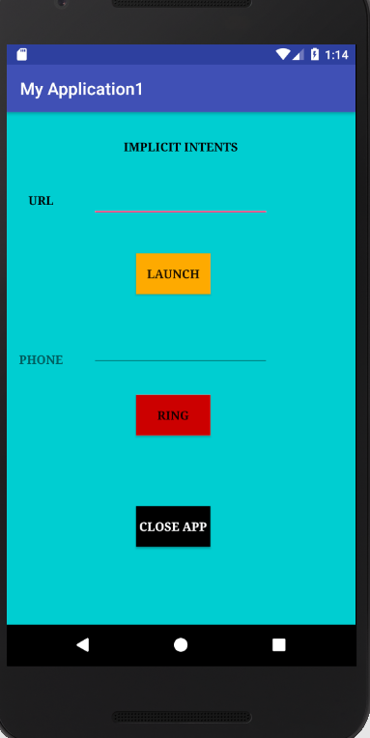

1. We can give desired URL that we want to launch, and Launch will give a list of all browser present in the emulator which will launch this URL using intent “ACTION_VIEW”. For Example, <http://linkedin.com> .

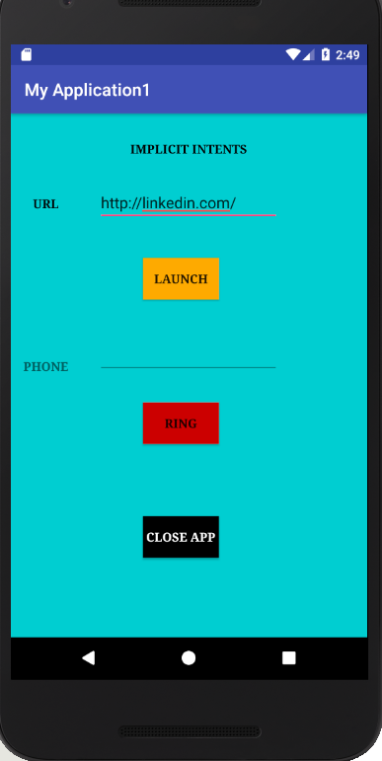

1. Launch will open <https://www.linkedin.com> on the selected browser.

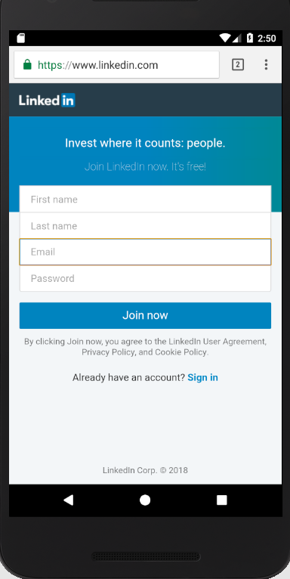

1. We can enter desired Phone Number in Phone Text view and Click on “Ring” and it will open dial pad and call the desired number using intent “ACTION_VIEW”.

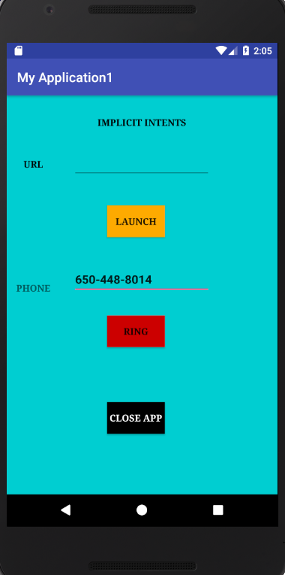

1. Number dialed using dial pad which is present in emulator.

